Advanced SQL Server
Exercise 1 - Ranking and Window Functions:

CREATE DATABASE CompanyDB13;
USE CompanyDB13;
CREATE TABLE Employee(
EmployeeID INT PRIMARY KEY, EmployeeName VARCHAR(50), Department VARCHAR(30),
Salary DECIMAL(10,2)
);
INSERT INTO Employee VALUES
(101,'Akshay','IT',65000),
(102,'Priya','HR',45000),
(103,'Rahul','IT',75000),
(104,'Sneha','Finance',60000),
(105,'Arjun','IT',65000),
(106,'Meena','HR',50000);
- SELECT EmployeeID, EmployeeName, Department, Salary, ROW_NUMBER() OVER(ORDER BY Salary DESC) AS RowNumber FROM Employee;
Output:
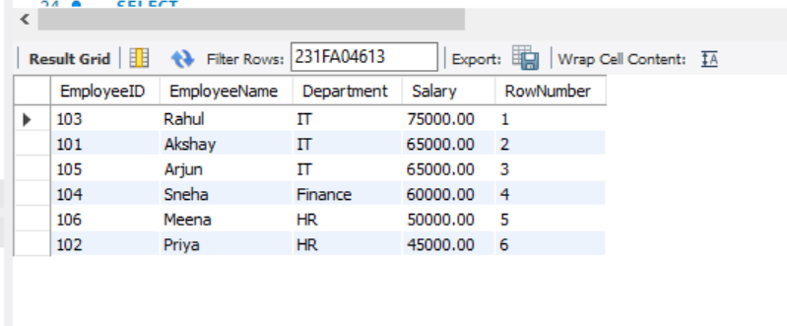

- SELECT EmployeeName, Salary, RANK() OVER(ORDER BY Salary DESC) AS RankNumber FROM Employee;
Output:
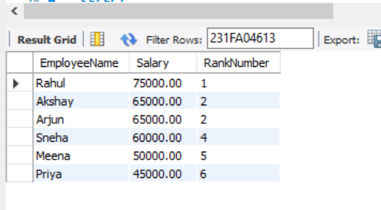
- SELECT EmployeeName, Salary, NTILE(2) OVER(ORDER BY Salary DESC) AS GroupNumber FROM Employee;
Output:
